Lecture B2
Wired and Wireless LAN

1. Introduction
2. LAN, Ethernet LAN | a. Carrier Sense Multiple Access /  Collision Detection (CSMA/CD)
3. Multiple Accesses with Collision Avoidance (MACA) | a, Hidden and exposed terminals  b. MACAW
4. Wireless communication LAN
protocol stack
5. MAC Sublayer Protocol for 802.11
6. Medium Access with Carrier Sense
Multiple Access with
Collision Avoidance (CSMA/CA)
7. The 802.11 Frame Structure
8. Services
9. TCP Congestion Control
10. 802.11b MAC Protocol Review
11. Problems of TCP/UDP over
802. 11b Wireless Networks

References:
[2]. pg.247-292; 317-43268-71; 134-137; 267-270; 292-310; 208-211; 462-464, 553-555

- introduction

The use of Wireless LANs (WLANs), also called Wi-Fi, is growing rapidly; a recent survey of network managers indicated that 90 percent of companies are using wireless LANs. Wireless LANs transmit data through the air using radio transmission. Until recently, there were few widely accepted standards for wireless LANs, and as a result equipment from different vendors could not be used in the same network. WLANs serve the same purpose as LANs: They are used to connect a series of computers in the same small local area to each other and to a backbone network. WLANs usually are most commonly used to connect a set of wireless computers into a wired network. Wireless communication systems are based on transmission and reception of modulated signals.

2. LAN, Ethernet LAN

a. Carrier Sense Multiple Access / Collision Detection (CSMA/CD)

CSMA/CD is used on all Ethernet LANs. Ethernet uses a bus topology. In CSMA/CD, each station has equal access to the network, but it can broadcast only when the network is idle. Before transmitting, a station first listens to the network to sense if another workstation is transmitting carrier sense. If the network is still idle after a certain period, the station will transmit.

It is possible that two stations will listen and sense an idle network at the same time. Each will then transmit its message on the network, where the messages will collide. Neither message will be usable if a collision occurs. While transmitting, a station must perform collision detection to detect if its message was destroyed. If a collision is detected, the detecting station broadcasts a collision or jam signal to alert other stations that a collision has occurred. Each transmitting station then waits a random amount of time (ranging from 10 to 90 ms) before attempting the transmission again.

The CSMA/CD Ethernet protocol defined by IEEE standard 802.3. All information on an Ethernet network is organized into frames (also called packets). A frame includes all information necessary for successful transmission of the packet, plus the data to be transmitted. Figure 1 shows the frame format for Ethernet data transmission.
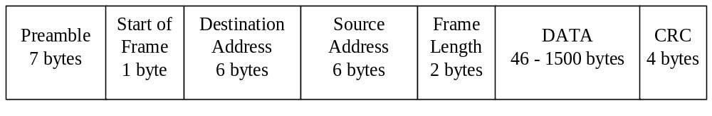
Figure 1: Contents of an Ethernet frame.

The preamble indicates the beginning of a transmission. It is a series of alternating 1’s and 0’s that allows the receiving stations to synchronize signal detection to the transmission.

The start of frame is a special eight-bit signal pattern, “10101011”, that signals the start of the packet information.

The destination address is the Ethernet address the station that is to receive the message. All Ethernet addresses are 6 bytes long, and every Ethernet station is manufactured with a unique Ethernet address. A destination address of all 1’s is the “broadcast” address; all stations on the network will receive a message sent to that address. The network can also define “multicast” addresses for groups of workstations. Each station listens for its own address, the broadcast address, and any multicast addresses for groups to which it belongs. The source address identifies the station initiating the transmission. The frame length indicates how many bytes are in the data portion of the packet. The data is the information transmitted.

The cyclic redundancy check (CRC) is found from the bit pattern of the entire previous contents of the packet, using a mathematical formula. If the CRC is incorrect, there was a transmission error somewhere in the packet, and the entire packet must be retransmitted.

All bits in an Ethernet frame are encoded in Manchester code (see reading Lecture). This code represents a 0 as a high-to-low voltage transition, and a 1 as a low-to-high voltage transition. This coding scheme is much more reliable than NRZ coding, but requires twice the bandwidth, since each bit is encoded as a two-bit NRZ sequence (0 becomes 1-0, and 1 becomes 0-1).
The frequency of collisions will limit the efficiency of an Ethernet network. If too many simultaneous data transmissions are attempted, the rate of collisions will become probable high. An Ethernet is optimal for networks where each station transmits only intermittently, and the probability of many stations transmitting simultaneously is fairly low. In typical Ethernet implementations, collisions will limit the efficiency to about 40% of the maximum possible packet transmission rate. If only one station is transmitting, the efficiency can increase to about 90% (since it must provide inter-frame spaces to monitor the network for other traffic).
3. Multiple Accesses with Collision Avoidance (MACA)

a, Hidden and exposed terminals

The situation in wireless networks is different than in wired networks. To achieve mobility, notebook computers need to use radio signals for communication. A system of notebook computers that communicate by radio can new regarded as a wireless LAN. These LANs have somewhat different properties than wired LANs and require special MAC sublayer protocols. In this chapter we will examine some of these protocols.

A common configuration for a wireless LAN is an office building with base stations (access points) strategically placed around the building. All the base stations are wired together using cupper or fiber. If the transmission power of the base stations and notebooks is adjusted to have a range of 3 or 4 meters, then each room becomes a single cell and the entire building becomes a large cellular system, as in the traditional cellular telephony systems.

In our discussion below, we will make the simplifying assumption that all radio transmitters have some fixed range. When a receiver is within range of two active transmitters, the resulting signal will be garbled and useless, in other words, we will not consider CDMA-type systems further in this discussion. It is important to realize that in some wireless LANs, not all stations are within range of one another, which leads to a variety of complications. Furthermore, for indoor wireless LANs, the presence of walls between stations can have a major impact on the effective range of each station.

An inexperienced approach to using wireless LAN might be to try CSMA: just listen for other transmissions and only transmit if no one else is doing so. The trouble is that, this protocol is not really appropriate because what matters is interference at the receiver, not at the sender. To see the nature of the problem, see figure below, where four wireless stations are illustrated. For our purposes, it does not matter which are base stations and which are notebooks. The radio range is such that A and B are within each other’s range and can potentially interfere with one another. C can also potentially interfere with both B and D, but potentially not interfere with A.

First consider what happens when A is transmitting to B, as depicted in a). If C senses the medium, it will not hear A because A is out of range, and thus falsely conclude that it can transmit to B.
A
B
C
D
A
B
C
D
Radio range
a
b
Figure 2. Hidden and exposed stations problems

If C does start transmitting, it will interfere at B, wiping out the frame from A. The problem of a station not being able to detect a potential competitor for the medium because the competitor is too far away is the hidden station problem.

Now let us consider the reverse situation: B transmitting to A, as shown in b). If C senses the medium, it will hear an ongoing transmission and falsely conclude that it may not send to D, when in fact such a transmission would cause bad reception only in the zone between B and C, where neither of the intended receivers is located. This is called exposed station problem.

The problem is that before starting a transmission, a station really wants to know whether activity around the receiver is. CSMA just tells it whether there is activity around sensing the carrier. With a wire, all signals propagate to all stations so only one transmission can take place anywhere in the system. In a system based on short-range radio waves, multiple transmissions can occur simultaneously is they all have different destinations and these destinations are out of range of one another.

Another way to think about this problem is to imagine an office building in which every employee has a wireless notebook computer, there many different variants of collisions could be occurred.

An early protocol designed for wireless LANs is Multiple Access with Collision Avoidance (MACA). The basic idea is for the sender to stimulate the receiver into outgoing a short frame, so stations nearby can detect this transmission and avoid transmitting for the duration of the upcoming (large) data frame. MACA is illustrated in Figure 3. It shows how A sends a frame to B. A starts by sending an RTS (Request To Send) frame to B. This short frame (30 bytes) contains the length of the frame that will eventually follow. Then B replies with a CTS (Clear to Send) frame. The CTS frame contains the data length (copied from the RTS frame). Upon receipt of the CTR frame, A begins transmission.

Now let us see how stations overhearing either of these frames react. Any station hearing the RTS is clearly close to A and must remain silent long enough for the CTS to be transmitted back to A without conflict. Any station hearing the CTR is clearly close to B and must remain silent during the upcoming data transmission, whose length it can tell by examining the CTS frame.

In Figure 3, C is within range of A but not within range of B. Therefore, it hears the RTS from A, but not the CTS from B. As long as it does not interfere with the CTS, it is free to transmit while the data frame is being sent. In contrast, D is within range of B but not A. It does not hear the RTS but hear the CTS. Hearing the CTS tips it off that is close to a station that is about to receive a frame, so it defers sending anything until that is expected to be finished. Station E hears both control messages and, like D, must be silent until the data frame is complete.

Regardless of these precautions, collision can still occur. For example, B and C could both send RTS frames to A at the same time. These will collide and be lost. In the event of collision, an unsuccessful transmitter (i.e., one that does not hear a CTS within the expected time interval) waits a random amount of time and tries again later. The algorithm used is binary exponential backoff, which we study with Ethernet.

C
E
A
B
D
RTS
C
E
A
B
D
CTS
(a)
(b)
Figure 3. The MACA protocol: (a) A sending an RTS to B; (b) B responding with a CTS to A.

- MACAW

Based on simulation studies of MACA, new improved protocol (Bharghavan) MACAW (for Wireless) was performed. To start with, hi noticed that, without DLL acknowledgment lost frames were not retransmitted until the transport layer noticed their absence, much later. Hi solved this problem by introducing an ACK frame after each successful data frame. Hi also observed that CSMA has some use, namely, to keep a station from transmitting an RTS at the same time another nearby station is also doing so to the same destination, so carrier sensing was added. In addition, hi decided to run the backoff algorithm separately for each data stream (source-destination pair), rather than for each station. (Binary exponential backoff: In CSMA/CA networks and CSMA/CD networks, the algorithm used to schedule retransmission after a collision, such that the retransmission is delayed by an amount of time derived from the slot time and the number of attempts to retransmit). This change improves the fairness of the protocol. Finally, to improve system performance, he added a mechanism for stations to exchange information about congestion, and a way to make the backoff algorithm react less violently to temporary problems.

Schemes with one master (base) station and several slave (mobile) stations is used polling mechanism, where one station is to be heard by all others, polling schemes can be applied. The master can poll the slaves according to many schemes: round robin, randomly, by reservation etc. The master could also establish a list of stations wishing to transmit during a contention phase. After this phase, the station pools each station on the list. Similar schemes are used in the Bluetooth wireless PAN and as one possible access in IEEE 802.11 systems.

4. Wireless communication LAN protocol stack

The protocols used by all 802 variants, including Ethernet, have certain similarity of structure. Part of 802.11 protocol stack is given in diagram, Figure 4. The physical layer corresponds to the OSI physical layer, but the DLL in all the 802 protocols is split into two or more sublayers. In 802.11, the MAC sublayer determines how the channel is allocated, that is, who gets to transmit next. Above it is the Logical Link Control (LLC) sublayer, whose job it is to hide the differences between the different 802 variants and make them indistinguishable as far as the network layer is concerned.
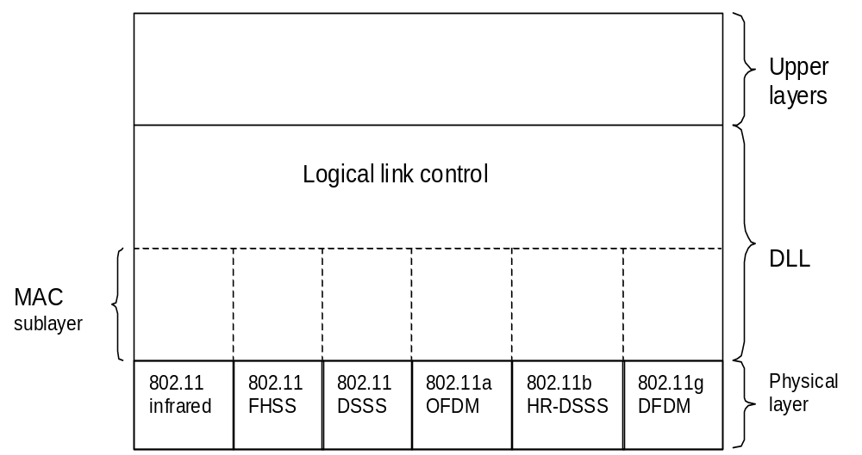

Figure 4. Part of the 802.11 protocol stack

The 802.11 standard specifies three transmission techniques allowed in the physical layer: The infrared method uses much the same technologies as television remote control do. The other two use short-range radio, using techniques of FHSS and DSSS. Both of these use a part of the spectrum that does not require licensing (2.4 GHz) ISM (Industrial, Scientific, and Medical application) band.

Notebook computers, radio-control garage door opener’s, cordless telephone and microwave ovens all these techniques use the same frequency band, and operate at 1 to 2 Mbps, so each of them are generating noise for each others, but at low enough power that they do not conflict too much. Later two new techniques were introduced to achieve higher bandwidth. These are called OFDM (Orthogonal Frequency Division Multiplexing) and HR-DSSS (High Rate DSSS). They operate at up to 54 Mbps and 11 Mbps, respectively. DSSS has some similarities to the CDMA system, but differs in other ways. Each bit is transmitted as 11 chips, using so called a Barker sequence. It uses phase shift modulation.

Since May 2002, the first of the high-speed LANs, 802.11a, uses OFDM to deliver up to 54 Mbps in the wider 5-GHz band. Different frequencies are used (52), 48 of them for data and 4 for synchronization. Since transmissions are present on multiple frequencies at the same time, this technique is considered as a form of spread spectrum, but different from both CDMA and FSSS. Splitting the signal into many narrow bands has some key advantages over using a single wide band, including better immunity to narrowband interference and the possibility of using noncontiguous bands.

Frequency hopping is an ideal strategy for a WLAN network in a noisy frequency band. All data is placed into packets before being transmitted over the network and each packet has a CRC to detect bit errors. Any one error in a packet will cause the entire packet to be discarded. Each frequency hop consists of some number of data packets, and the last data packet completes transmission before the frequency changes. Missed packets can be recovered through the transmission protocol, so a small packet loss rate is acceptable. A WLAN system must minimize the packet error rate caused by strong transient noise.

If the WLAN used a DSSS strategy, a strong transient noise would create a small bit error rate during its entire length, causing most or all packets to be discarded. With FHSS, a strong transient noise somewhere in the frequency band will interfere with the signal only while the signal is hopping in the same channel as the noise. Packets transmitted during this hop will be lost, but the signal will soon hop away from this frequency. Packets on the next hop will transmit successfully.

FHSS has several advantages for WLAN equipment:
• WLAN systems can overlap without interference
• Immunity from noise and interference
• Resistance to radio reflections (multipath transmission)
• High data transfer capacity
• Low price for decoder and transmitter
5. MAC Sublayer Protocol for 802.11

The 802.11 MAC sublayer is quite different from that of Ethernet due to the inherent complexity of the wireless environment compared to that of a wired system. With Ethernet, a station just waits until the other goes. With wireless, this situation does not hold, see Figure 8. Since not all stations are within radio range of each other, transmission going on in one part of a cell may not be received elsewhere in the same cell. In this example (Figure 8a), station C is transmitting to station B. If A senses the channel, it will not hear anything and falsely conclude that it may now start transmitting to B.

In addition, there is the inverse problem, the exposed station problem, illustrated in Figure 8 (b). Here B wants to send to C, it listens the channel. When it hears a transmission, it falsely concludes that it may not send to C, since A may be transmitting to D (not shown). In addition, most radios are half duplex, meaning that they cannot transmit and listen for noise bursts at the same time on a single frequency. As a result of these problems, 802.11 does not use CSMA/CD, as does Ethernet.

To deal with this problem 802.11, when many users are located in the same area, and use the same wireless LAN at the same time, two different access methods are defined to supports two modes of operations:

1. Called DCF (Distributed Coordination Function), does not use any kind of central control (in that respect, similar to Ethernet).
2. Called PCF (Point Coordination Function), uses the base station to control all activity in its cell. All implementations must support DCF.

We will now discuss these two modes in turn. When DCF is employed, 802.11 uses a protocol called Medium Access with Carrier Sense Multiple Access with Collision Avoidance (CSMA/CA).

6. Medium Access with Carrier Sense Multiple Access with
Collision Avoidance (CSMA/CA)

The basic access mechanism, called the Distributed Coordination Function, is a Carrier Sense Multiple Access (CSMA) algorithm, but with a Collision Avoidance mechanism. In this protocol, both physical channel sensing and virtual channel sensing are used. Two methods of operations are supported by CSMA/CA:
1). Each unit senses the medium before it starts to transmit. If the medium is free for several microseconds, the unit can transmit for a limited time. It does not sense the channel while transmitting, but emits its entire frame, which may be destroyed at the receiver due to interference there. If the medium is busy, the unit will back off for a random time before it senses again. Since transmitting unit competes for airtime, the protocol should ensure equal access of the stations.

Carrier Sense Multiple Access (CSMA) Collision Detection (CD) Mechanisms are effective on a wired LAN, but they cannot be used on a wireless LAN environment for two main reasons:

• Implementing a Collision Detection mechanism would require the implementation of a full-duplex radio capable of transmitting and receiving at the same time, an approach that would increase the price significantly.
• In a wireless environment we cannot assume that all stations can hear each other (a basic assumption of the CD scheme). In the wireless LAN, if a station senses the medium is free, it does not necessarily mean that the medium is free throughout the entire cell.

In order to overcome these problems, IEEE Standard 802.11 implemented a Collision Avoidance (CA) mechanism through a Positive Acknowledge Scheme.

2). This scheme defines a Virtual Carrier Sense (VCS) mechanism that reduces the probability of two stations colliding, because: Is based on MACAW and uses virtual channel sensing, as illustrated in Figure 5.

A wants to send to B. C is station within range of A (and possible within range
of B, (but that does not matter). D is a station within range of B but not within
range of A.

Protocol starts when A decides it wants to send data to B. It begins by sending an RTS frame to B to request permission to send it a frame. When B receives this request, it may decide to grant permission, in which case it sends a CTS frame back. Upon receipt of the CTS, A now sends its frame and starts an ACK timer. Upon correct receipt of the data frame, B responds with an ACK frame, terminating the exchange. If A’s ACK timer expires before the ACK gets back to it, the whole protocol is run again.

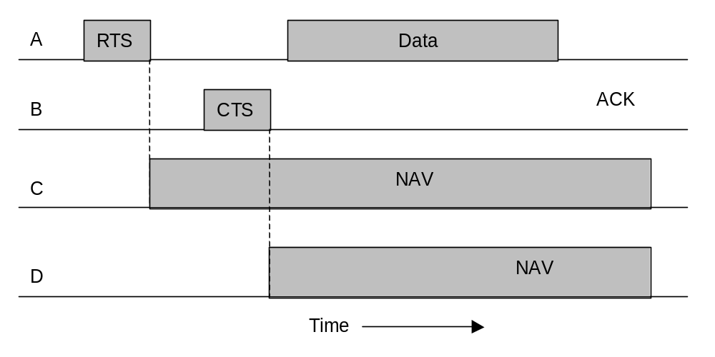
Figure 5. The use of Virtual Channel Sensing using CSMA/CA.

Now let us consider this exchange from the viewpoints of C and D. C is within range of A, so it may receive the RTS frame. If it does, it realizes that someone is going to send data soon, so for the good of all it desists from transmitting anything until the exchange is completed.

From the provided in the RTS request, it can estimate how long the sequence will take, including the final ACK, so it asserts a kind of virtual channel busy for itself, indicated by NAV (Network Allocation Vector), Figure 5. D does not hear the RTS, but it does hear the CTS, so it also asserts the NAV signal for itself. Note that the NAV signals are not transmitted; they are just internal reminders to keep quiet for a certain period of time.

In contrast to wired networks, wireless networks are noisy and unreliable, in no small part due to microwave ovens. As a consequence, the probability of a frame making it through successfully decreases with frame length.
If the probability of any bit being in error is p, then the probability of an n-bit frame being received entirely correctly is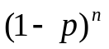. For example, for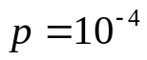, the probability of receiving a full Ethernet frame (12,144 bits) correctly is less than 30%, if 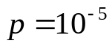, about one frame in 9 will be damaged. Even if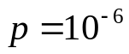, over 1% of the frames will be damaged, which amounts to almost a dozen per second, and more if frames shorter than the maximum are used. In summary, if a frame is too long, it has very little chance of getting through undamaged and have to be retransmitted.

To deal with the problem of noisy channels, 802.11 allows frames to be fragmented into smaller pieces, each with its own checksum. The fragments are individually numbered and acknowledged using a stop-and-wait protocol (i.e. the sender may not transmit fragment k+1 until it has received the acknowledgment for fragment k). Once the channel has been acquired using RTS and CTS, multiple fragments can be sent in a row, as shown in Figure 6. Sequence of fragments is called a fragment burst.

Fragment burst
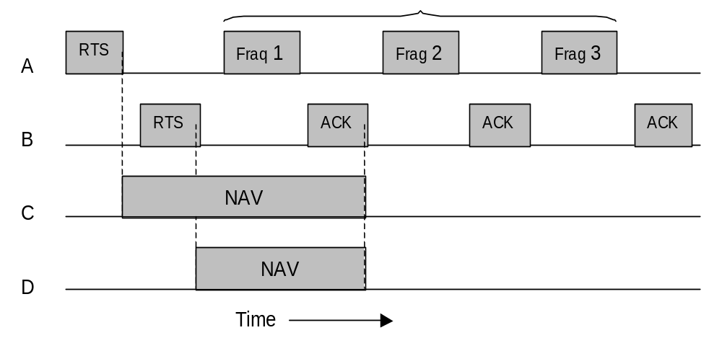
Figure 6. A Fragment burst.

Fragmentation increases the throughput by restricting retransmissions to the bad fragments rather than the entire frame. The fragment size is not fixed by the standard but is a parameter of each cell and can be adjusted by the base station. The NAV mechanism keeps other stations quiet only until the next acknowledgment, but another mechanism is used to allow a whole fragment burst to be sent without interference.
All of the above discussion applies to the 802.11 DCF mode. In this mode, there is no central control, and stations compete for air time, just as they do with Ethernet.

The other allowed mode is PCF (Point Coordination Function), in which the base station polls the other stations, asking them if they have any frames to send. Since transmission order is completely controlled by the base station in PCF mode, no collision over occur.

The standard prescribes the mechanism for polling, but not the polling frequency, polling order, or whether all stations need to get equal service. The base mechanism is for the base station to broadcast a beacon frame periodically (10 to 100 times per second). The beacon frame contains system parameters, such as hopping sequences and dwell times (for FHSS), clock synchronization, etc.

It also invites new stations to sign up for polling service. Once a station has signed up for polling service at a certain rate, it is effectively guaranteed a certain fraction of the bandwidth, thus making it possible to give equality-of-service guarantees.

To save battery power 802.11 pays attention of power management. In particular, the base station can direct a mobile station to go into sleep state until explicitly awakened by the base station or the user. In this time the base station has the responsibility for buffering any frames directed at it while the mobile station is asleep. These can be collected later. PCF and DCF can coexist within one cell. At first it might seem impossible to have central control and distributed control operating at the same time, but 802.11 provides a way to achieve this goal.

It works by carefully defined the interframe time interval. After a frame has been sent, a certain amount of dead time is required before any station may send a frame. Four different intervals are defined, each for a specific purpose, see Figure 7. The shortest interval is SIFS (Short Interframe Spacing). It is used to allow the parties in a single dialog the chance to go first. This includes letting the receiver send a CTS to respond to an RTS, letting the receiver send an ACK for a fragment or full data frame, and letting the sender of a fragment burst transmit the next fragment without having to send RTS again. There is always exactly one station that is entitled to respond after a SIFS interval. If it fails to make use of its chance and a time PIFS (PCF Inter Frame Spacing) elapses (passes), the base station may send a beacon frame or poll frame.

This mechanism allows a station sending a data frame or fragment sequence to finish its frame without anyone else getting in the way, but gives the BS a chance to seize the channel when the previous sender. If the is done without having to compete with impatient users, BS has nothing to say and a time DIFS (DCF Inter Frame Spacing) elapses, any station may attempt to acquire the channel to send a new frame. The usual contention rules apply, and binary exponential backoff may be needed if collusion occurs.

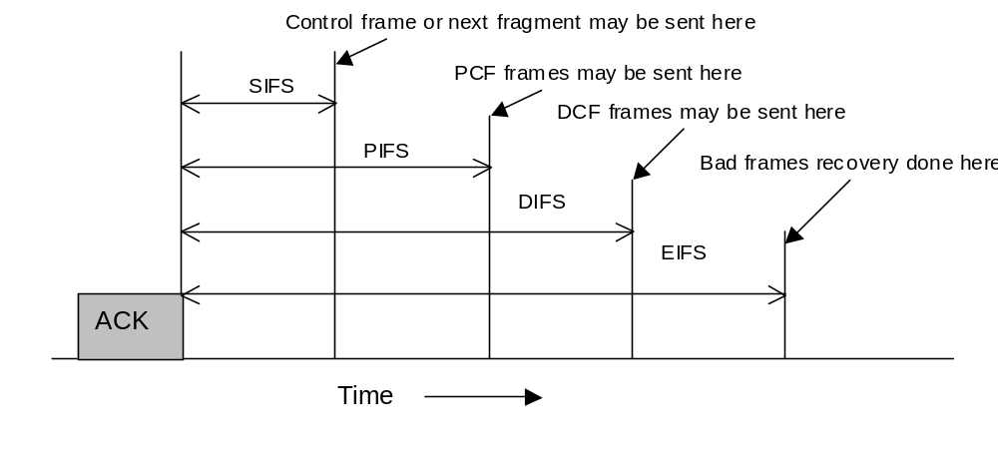
Figure 7. Interframe spacing for 802.11.

The last time interval, EIFS (Extended Interframe Spacing), is used only by a station that has just received a bad or unknown frame to report the bad frame. The idea of giving this event the lowest priority is that since the receiver may have no idea of what is going on, it should wait a substantial time to avoid interfering an ongoing dialog between two stations.

Full process of signal transmitting finally could be expressed by following steps:

1. A station that wants to transmit will first check to see if another station has reserved the medium. If not, the station senses the medium for a specified time called the Distributed Inter Frame Space or DIFS for other stations requesting the medium. If no other station transmits, then the station will transmit a short RTS (Required To Send) packet. This packet includes the source address, destination address, and duration of the following transmission. The duration is the total transmission time for all further packets that will be transmitted (CTS, data, and acknowledgment) plus inter-frame spaces.

2. The Access Point responds (if the medium is free) with a response control packet called Clear To Send (CTS), which includes the same duration information. Receipt of the CTS packet indicates to the transmitter that no collision occurred, and permission is granted to start the data transmission. If the transmitter does not receive a CTS packet, then it repeats part 1 until it either receives acknowledgment or times out after a given number of re-transmissions.

3. The CTS frame is received by all the stations in the cell, notifying them that another unit will transmit during the following X microseconds. These stations record this information so they will know when the medium will again be available. These stations may not have received the RTS packet because the original transmitting unit is out of range.

4. The transmitting station sends its data frame to the access point. After the data frame is transmitted, the access point checks the CRC of the packet and, if correct, returns an Acknowledge (ACK) packet to confirm successful transmission.

5. If the final destination is another station on the WLAN, the access point then reserves the medium with a CTS packet. It proceeds to retransmit the data frame. The destination station checks the CRC of the packet and, if correct, returns an ACK to the access point.

The transmitting station repeats this process for every packet transmitted. If the Access Point is the originating station for the packet, only step 5 above is needed. The access point reserves the medium by transmitting a CTS packet if it senses the medium is free, and transmits its packet.

The duration information in the CTS packet protects the data transmission from collisions. Because the RTS and CTS are very short packets, this mechanism also reduces the overhead of collisions, since these are recognized faster than if the whole packet was to be transmitted.

If the data packet is very short, the RTS packet may include all the data to be transmitted. On a collision, the overhead will not be significantly higher than with a short RTS packet. If the RTS contains data, the CTS packet contains a duration of zero, and simply functions as an acknowledgement to the transmitter that the RTS packet with data was received.

Typical WLAN protocols use packets several hundred bytes long (up to 1518 bytes). These packets are much smaller than Ethernet packets. It is preferable to use smaller packets in a wireless environment for several reasons:

• Due to the higher Bit Error Rate of a radio link, the probability of a packet getting corrupted increases with the packet size.
• In the case of packet corruption (due to collision or noise), a smaller the packet requires less overhead if it is necessary to re-transmit.

Using FHSS, the medium access is interrupted periodically for hopping (dwell times are 32, 64 and 128 milliseconds). If the packet is smaller, its transmission is less likely to be postponed until after the dwell time.

7. The 802.11 Frame Structure

802.11 standard defines three different classes of frames: data, control and management. These three main types of frames are:
1. Data Frames used for data transmission.
2. Control Frames, used to control access to the medium (RTS, CTS).
3. Management Frames, which exchange management information and are transmitted in the same manner as data frames, but are not forwarded to upper layer. These frames are used for synchronization, authentication, and power management.

Each of these has a header with a variety of fields used within the MAC sublayer. Each frame type is subdivided into different subtypes, according to their specific function. Frames are composed of the following components:

• The Preamble contains synchronization information for the physical layer.
Data Frame
• The Personal Link Control Protocol (PLCP) Header contains the packet length and transmission rate information that is used by the physical layer to decode the frame. It is always transmitted at 1 Mbps.
• The MAC Data Frame Format contains the routing information and message body.
• The header cyclic redundancy check (CRC) is 16 bits long, and performs error detection on the header information.

The RTS frame contains no data, and uses a shortened MAC header with no frame body. The MAC data frame has the following structure:
RTS Frame
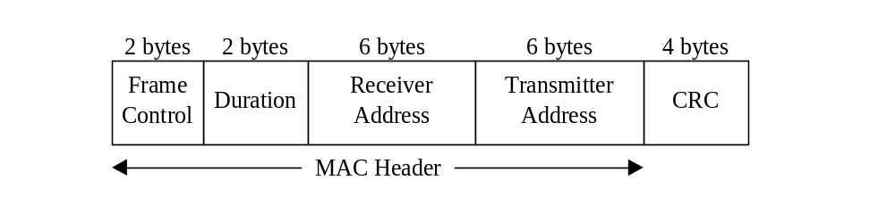
The duration value is the time in microseconds required to transmit the next data or management frame, plus one CTS frame, one ACK frame, and three SIFS intervals.

The CTS frame also contains no data. Its MAC data frame has the same structure as the RTS frame, with the Frame Control field changed to indicate a CTS packet. The Receiver Address is copied from the original RTS frame Transmitter Address.

CTS Frame
The ACK frame is sent by the recipient of a data packet to confirm receipt, and allow the transmitting station to send the next packet. The Receiver Address is copied from the data frame Transmitter Address. The MAC data frame contains a header with addressing information, the frame body, and a 32-bit CRC check of the entire MAC frame.

The Protocol version allows two versions of the protocol to operate at the same cell. Then come the Type (data, control, or management) and subtype fields (e.g., RTS or CTS). The To DS and From DS bits indicate the frame is going to or coming from the intercell distribution system (e.g., Ethernet). The MF bit means that more fragments will follow. The Retry bit makes a retransmission of a frame sent earlier. The Pwr management bit is used by the base station to put the receiver into sleep state or take it out of sleep state. The More bit indicates that the sender has additional frames for the receiver. The W bit specifies that the frame body has been encrypted using the WEP (Wired Equipment Privacy) algorithm. Finally, the 0 bit tells the receiver that a sequence of frames with this bit on must be passed strictly in order.

ACK Frame
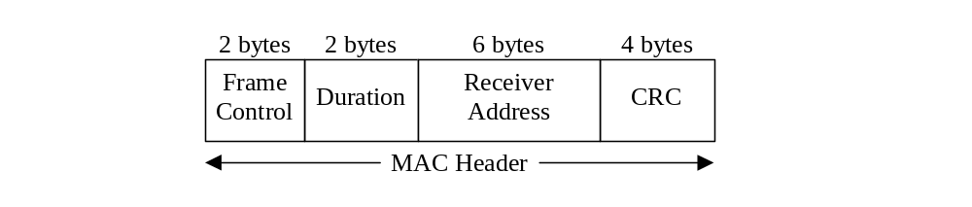
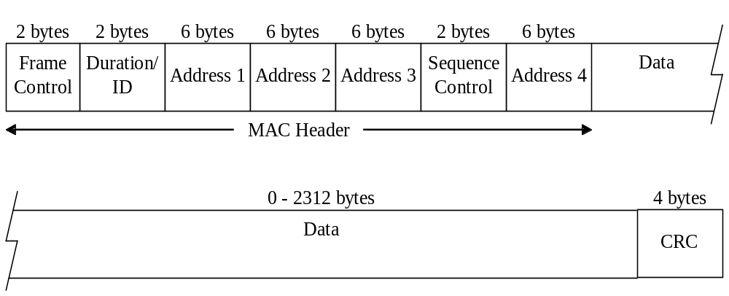
Figure 8a. The 802.11 data frame.

In the frame format first comes the Frame Control field. It itself has 11 subfields, Figure 8b.
2 2 4 1 1 1 1 1 1 1 1
Version
Type
Subtype
To
DS
From
DS
MF
Re
try
Pwr
More
W
0
Bits

Figure 8b. Frame Control field.

Descriptions of the following fields are clearly explained by the corresponding names, just need to explain Sequence field that allows fragments to be numbered. Of the 16 bits available, 12 identify frame and 4 identify the fragment. The data field contains the payload, up to 2312 bytes, followed by the usual checksum.

Management frames have a format similar to that of data frames, except without one of the base station addresses, because management frames are restricted to a single cell. Control frames are shorter still, having only one or two addresses, no Data field, and no Sequence field. The key information here is in the Subtype field, usually RTS, CTS, or ACK. Fragmentation of packets into shorter fragments adds protocol overhead and reduces the protocol efficiency when no errors are expected. Each packet must contain a MAC header and a CRC (Figure 9). However, if errors are likely to occur, fragmentation reduces the amount of time necessary for retransmissions. Un-fragmented long packets will be more likely to have an error that will require retransmission, and the retransmission time will be greater.
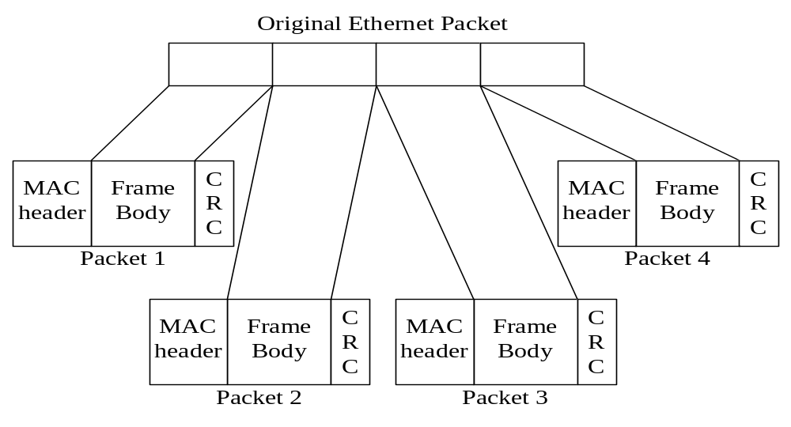
Figure 9. Frame fragmentation
8. Services

The 802.11 standard states that each wireless LAN must provide nine services. These services are divided into two categories:
1. Five distribution services (provided by BS) and
2. Four station services.

Distribution services relate to managing cell membership and interacting with stations outside the cell. In contrast, the station services relate to activity within a single cell.

The five distribution services are provided by the base stations and deal with station mobility as they enter and leave cells, attaching themselves to and detaching themselves from base stations. They are as follows:

1. Association. This service is used by MS to connect themselves to BS. Typically, it is used just after a station moves within the radio range of the BS. Upon arrival, it announces its identity and capabilities. The capability include the data rates supported, need for PCF services (I.e., polling) and power management requirements. The BS may accept or reject the MS. If the mobile station is accepted, it must then authenticate itself.

2. Disassociation. Either the MS or the BS may disassociate, thus breaking the relationship. A MS should use this service before shutting down or leaving, but the BS may also use it before going down for maintenance.

3. Reassociation. A MS may change its preffered BS using this service. This facility is useful for MS moving from one cell to another. If it is used correctly, no data will be lost as a consequence of the handover. (But 802.11, like Ethernet, is just a best-effort service).

4. Distribution. This service determines how to route frames sent to the BS. If the destination is local to the BS, the frame can be sent out directly over the air. Otherwise, they will have to be forwarded over the wired network.

5. Integration. If a frame needs to be sent through a non-802.11 network with a different addressing scheme or frame format, this service handles the translation from the 802.11 format to the format required by the destination network.

The remaining four services are intercell (i.e., relate to actions within a single cell). They are used after asossiation has taken place and are as follows:

1. Authentication. Because wireless communication signal can easily be sent or received by unauthorized stations, a MS must authenticate itself before it is permitted to send data. After a MS has been associated by the BS (i.e., accepted into its cell). The BS sends a special challenge frame to it to see if the MS knows the secret key (password) that has been assigned to it. It proves its knowledge of the secret key by encrypting the challenge frame and sending it back to the BS. If the result is correct, the MS is fully enrolled in the cell. In the initial standard, the BS does not have to prove its identity to the MS, but work to repair this defect in the standard is underway.

2. Deauthentication. When a previously authenticated MS wants to leave the network, it is deauthenticated. After deauthentication, it may no longer use the network.

3. Privacy. For information sent over a wireless LAN to be kept confidential, it must be encrypted.

4. Data delivery. Finally, data transmission is what it is all about, so 802.11 naturally provides a way to transmit and receive data. Since 802.11 is modeled on Ethernet and transmission over Ethernet is not guaranteed to be 100% reliable, transmission over 802.11 is not guaranteed to be reliable either. Highed layers must deal with detecting and correcting errors. An 802.11 cell has some parameters that can be inspected and, in some cases, adjusted. They relate to encryption, timeout intervals, data rates, beacon frequency, and so on.

9. TCP Congestion Control

Reliable transport protocols such as TCP are tuned to perform well in traditional networks where packet losses occur mostly because of congestion. However, networks with wireless and other lossy links also suffer from significant losses not only from congestion but also due to interference, fading, multipath effects, and other wireless medium characteristics. TCP responds to all such losses, both wireless and congestion related, by invoking congestion control and avoidance algorithms, resulting in degraded end tuned performance in wireless and lossy systems.

The IEEE 802.11b MAC protocol attempts to screen upper layer (e.g. TCP) traffic from the busty loss nature of the wireless channel by employing link-layer ACKs and subsequent link-layer retransmissions up to some retransmission limit. Although link-layer retransmissions can prevent TCP from going into congestion control/avoidance due to random wireless losses, the negative effect of these retransmissions is highly variable round-trip times, unsuitable for non-TCP traffic (e.g. UDP voice/video).

In summary, there is an interesting interplay of link-layer retransmissions coupled with the congestion control/avoidance algorithms of TCP, interplay between lower layer protocols and upper layer protocols leads to problematic effects of heterogeneous traffic over 802.11b wireless networks.

TCP seeks to meet the following four primary goals:
- Reliable transport,
- High network utilization,
- Avoidance of network congestion, and
- Sharing of bandwidth.

Often these goals are mutually exclusive, and thus some sort of compromise must be made between them in an acceptable way (e.g. sharing bandwidth vs. high network utilization). TCP uses a sliding window mechanism-congestion window coupled with cumulative ACKs to implement the above four goals.

The size of the congestion window effectively dictates the level of pipelining of packets in a given network, and is the primary source of control over the network utilization of a given TCP sender. In an ideal scenario without any other competing TCP flows, the congestion window of a TCP sender should be exactly equal to the total number of packets that can be pipelined between the sender and receiver. Since the rate of the TCP sender is simply the size of this window over the total RTT, one can express the source rate as:
Source rate = window size / RTT
Thus, the following formula can be used to approximate the size of the ideal congestion window in these circumstances:
Window size = bandwidth * RTT
Unfortunately in reality a given TCP flow can never know the actual bandwidth of the network (it appears as a black-box due to the IP layer), and further, the TCP source must somehow share the network with other competing flows. As a result, TCP employs a set of congestion control algorithms to attempt to set the window size over time in a manner that causes our above four goals to be partially met in an acceptable compromise. Traditional TCP congestion control (TCP Reno) has four key phases:

Slow Start (SS),
Congestion Avoidance (CA),
Fast Retransmit (FT), and
Fast Recovery (FR).

In addition to having a varying Congestion Window (CWIN), TCP also employs a value called the “Slow Start Threshold” (SSTresh) to decide between SS and CA phases. A TCP sender initially begins in the SS phase, which begins with CWIN set to 1. On each successful ACK, we increment our CWIN by 1. Thus, this results in the exponential growth of the CWIN because in each RTT, CWIN = 2 * CWIN. When the CWIN finally exceeds SSTresh, TCP enters the CA phase, see Figure 10 and Figure 11.

When a packet loss is experienced (via timeout or duplicate acknowledgements), TCP assumes that the packet loss is due to network congestion (remember this for later). In the case of a timeout-detected packet loss, TCP sets the SSTresh to half the current CWIN, and the CWIN back to 1 and re-enters the SS phase, see Figure 12.

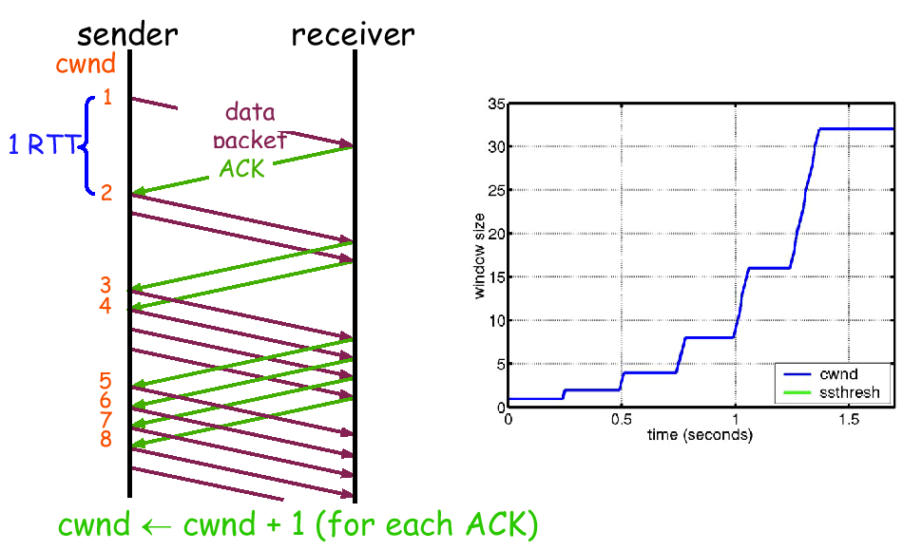

Figure 10. In congestion avoidance, CWIN >= SSTresh by definition, and on each successful ACK, CWIN = CWIN + 1/CWIN. Thus, over each RTT, we have linear growth of CWIN, CWIN = CWIN + 1. (As opposed to the exponential growth of the slow start phase).

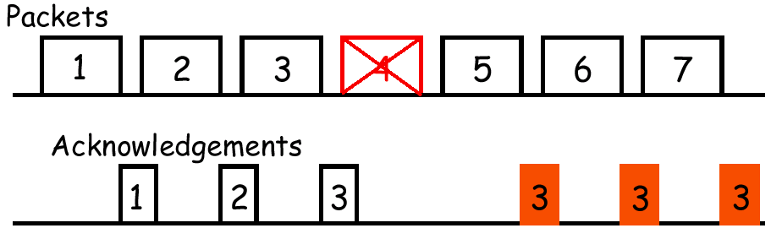
Figure 11. When we experience a packet loss, the TCP sender via one of two ways detects the packet loss: (a) a timeout expires for a sent packet, or (b) duplicate acknowledgments (we pick 3 as a good number in case of out-of-order delivery).

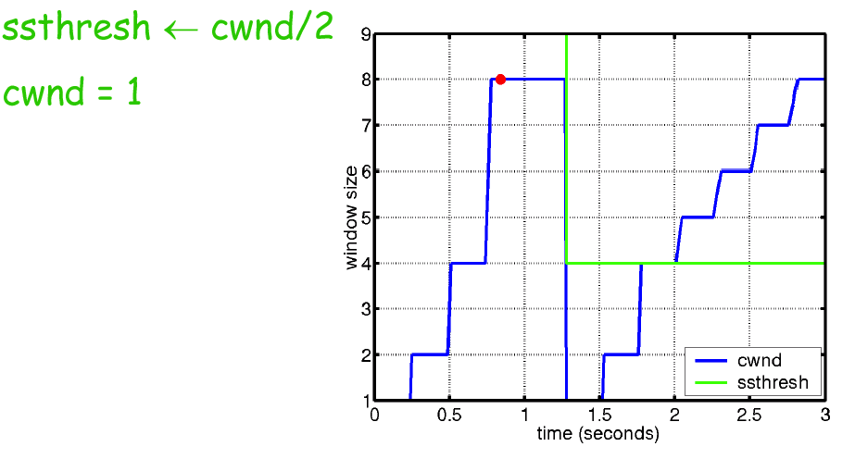
Figure 12. Since waiting for a timeout when a packet is lost may take quite a bit of time,

TCP immediately retransmits after three duplicate ACKs are receiving in a row without waiting for a timeout. Thus process is known as fast retransmit (FR). Additionally after a fast retransmit, TCP effectively sets the CWIN to half the SSTresh and CWIN to 1, reentering the SS phase.

The problem with the above fast retransmit scheme is that the pipe effectively “empties” due to the SS phase. Thus, we use the idea that each duplicate ACK represents a packet having left the pipe (successfully received). Thus, instead of doing the above “fast retransmit”, TCP Reno really does what is called “fast recovery” or “fast retransmit/fast recovery” (FR/FR) after receiving three duplicate ACK. The basic FR/FR procedure is the following:

- Set SSTresh = max (min(AWIN, CWIN) / 2, (where AWIN is the advertised window)
- Retransmit the lost packet
Set CWIN = SSTresh + Ndup (Ndup is a window inflation value)
- Wait until W = min(AWIN, CWIN) is large enough, and then transmit new packets
- On non-dup ACK (1 RTT later), set VWIN = SSTresh (window deflation)
- Enter CA phase. Graphically this looks like the following, (See Figure 13):

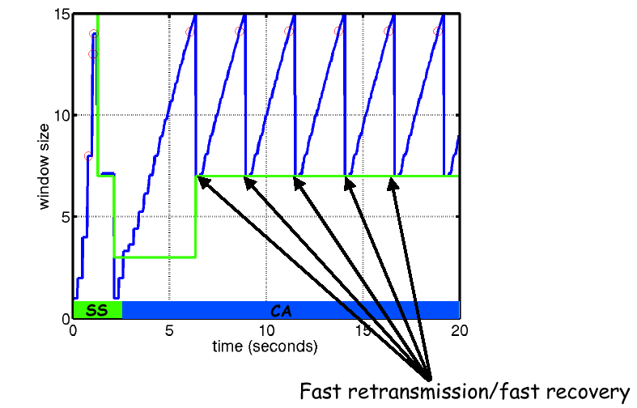

Figure 13. Thus, we have reviewed the behavior of TCP congestion control and avoidance algorithms. The key point to realize is that TCP invokes these algorithms under the assumption that packet loss is due to network congestion.

10. 802.11b MAC Protocol Review

Although the IEEE 802.11 standard is composed of multiple layers (from the physical layer up through the data-link layer), of particular interest is the 802.11b MAC layer because of its unique interaction with transport layer (TCP in particular). The basic access mechanism in 802.11b MAC is DCF, and is basically a carrier sense multiple access with collision avoidance mechanism. CSMA protocols are common within industry, the most notable being Ethernet which is a CSMA/CD protocol.

A CSMA protocol works as follows: a station desiring to transmit senses the medium; if it is busy (e.g. some other station is transmitting), the station will defer until a later time, and otherwise if the medium is sensed free, the station will transmit.

These types of protocols are very effective if the medium is not heavily loaded, since it allows stations to transmit with minimum delay. But, there is always a chance of two stations transmitting at the same time (if they both sense the medium free at the same moment).

Although Ethernet uses a CD technique to detect when two stations transmit simultaneously and collide, in the wireless environment it turns out that such collision detection cannot be implemented (due to the hidden terminal problem, and half-duplex radios). Thus, instead of using collision detection, 802.11b uses a CA mechanism coupled with a positive acknowledgment scheme.

A station ready to transmit will sense the medium first, if the medium is busy, and then it will defer. If the medium is free for a specified amount of time (called the distributed inter-frame space, DIFS), the station is allowed to transmit. The receiving station will check the CRC of the packet, and if the packet was received successfully, send an acknowledgement packet (ACK). If the sender does not receive the acknowledgment within a certain time interval, then the sender knows that there was a collision and will retransmit up to a certain retransmission limit. Before retransmitting, the sender will employ a random exponential backoff that prevents the colliding stations from retransmitting at the same exact moment.

In addition to ACKs, 802.11b employs so-called “virtual carrier sense” via the use of RTS/CTS packets. When a station wishes to send to another station, it may optionally first send a RTS packet (containing the length of the requested transmission) in the manner described above. The receiving station will respond with a CTS packet that all other hidden terminals of the sender can hear, with a time period specified that the sender will be allowed to transmit (the “network allocation vector”, or NAV). Other senders in the network will respect this CTS packet and corresponding NAV time, preventing collisions. Since RTS/CTS packets are very short, they minimize the overhead related to collisions if they do occur. In actual 802.11b implementations, RTS/CTS is only used when the length of a packet exceeds a “RTS threshold” – which on most typical cards is around 2Kb. Thus, typically RTS/CTS are very rarely used if ever in actual 802.11b networks.

The following diagram in Figure 19 illustrates the typical exchange between two 802.11b nodes in a network.

As mentioned earlier, 802.11b employs random exponential backoff in order to resolve contention after a collision in a crowded network. Effectively random backoff works as follows: the station will choose a random number between zero and a given number, and wait this number of slots before accessing the medium again, always checking again if the medium is busy before accessing. These slots times are defined in such a way so that a station can detect if another station is transmitting at the beginning of the previous slot. This effectively reduces the collision probability by half (e.g. ALOHA vs. slotted-ALOHA).

The exponential backoff means that each time a station chooses a slot and happens to collide; it will increase the maximum number for the random selection exponentially.

11. Problems of TCP/UDP over 802.11b Wireless Networks

As mentioned above, 802.11b has two key interesting properties related to upper layers: namely, link-layer (or MAC) retransmissions, as well as exponential backoff between such retransmissions. In actual 802.11b implementations, the maximum number of these link-layer retransmissions before dropping a packet is a configurable property of both the access point and the wireless network cards.

If the retransmission setting is relatively high, and there is a typical amount of wireless interference, then the retransmissions will effectively “shield” the upper layers from the effects of the wireless loss. However, since it may take multiple retransmissions before a single packet can be successfully transmitted, and because the multiple retransmissions will involve exponentially increasing backoff. It is clear that by varying the maximum retransmission setting, that one can see how a given MAC protocol can be more or less effective for different types of upper layer traffic. In the case of UDP traffic, jitter typically must be bounded to have high quality real-time voice or video, whereas reasonably high packet loss rates can be tolerated. However, in the case of data traffic, jitter is considerably less important than packet loss rate.

These effects on data traffic vs. real-time multimedia traffic are compounded by the congestion control/avoidance mechanisms of TCP. TCP is designed to assume that any packet loss is due to congestion, not wireless drops. Unfortunately, when packets are lost in networks for reasons other than congestion, these congestion control measures still result in an unnecessary reduction in throughput and hence, suboptimal performance. Communication over wireless links is often characterized by sporadic high bit error rates, and intermittent connectivity due to handoffs. TCP performance in such networks suffers from significant throughput degradation and very high interactive delays.

